1. Explanation of attached solution:
To ensure liveness:
- Priority will be given to the process that tries to get into the critical section first.
-whenever a process P1 is trying to get into the crictical section while it's occupied by another process P2, we need to make sure that P1 is handed the priority right after P2 is done.
-Also, when process P1 is in trying mode and process P2 is in neutral mode, P1 will enter the critical section directly without the need of any prioritization.
-To make a transition from state (C1,T2) to (N1,T2,F2) we need an intermediary state which will move process P1 from the critical state to the neutral state first before giving process P2 the priority.
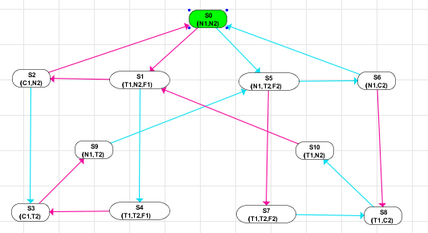

2. f = O1O2…Onp Oi is either F or G
In case of i = 1:
We end up with either Fp or Gp.
In case of i = 2:
We have 4 cases:
- FFp which means that p will be true some time in the future some time in the future, which is the same as Fp
- GGp which means that p will be globally true twice, which is the same as Gp.
- GFp => p is true in the future globally which is equivalent to Gp
- FGp => p is globally true in the future

For i = 3:
- FFFp = FFp = Fp -GGFp = GFp = Gp
- GGGp = GGP = Gp -FGGp = FGp
- GFFp = GFp = Gp -FFGp = FGp
- GFGp = Gp -FGFp = FGp

For i = n, we end up with 3 possible outcomes: Fp, Gp, or FGp.

